INTERNATIONAL DAY OF LOVE 14.12.2020
All together we can do everything. It doesn’t matter if we come from different countries, if we speak another language. Everyone needs love and friendship.

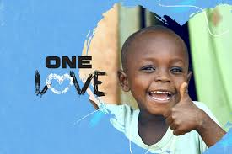
Around the world there are organizations which help kids from countries that need medical help. Love is taking care of someone.

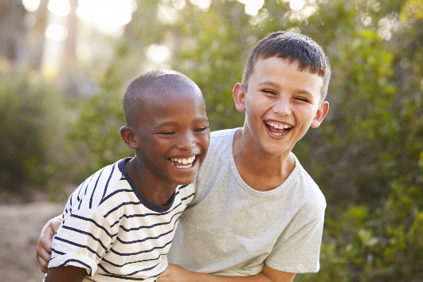
There is love between friends, too. A way to show their love to each other is to play games that they both like. Also, to make each other laugh.

Name: Dimitris Krommidas
Class: D1

