The white snow falls outside
The family is sitting around the fireplace
The Christmas tree lights shine 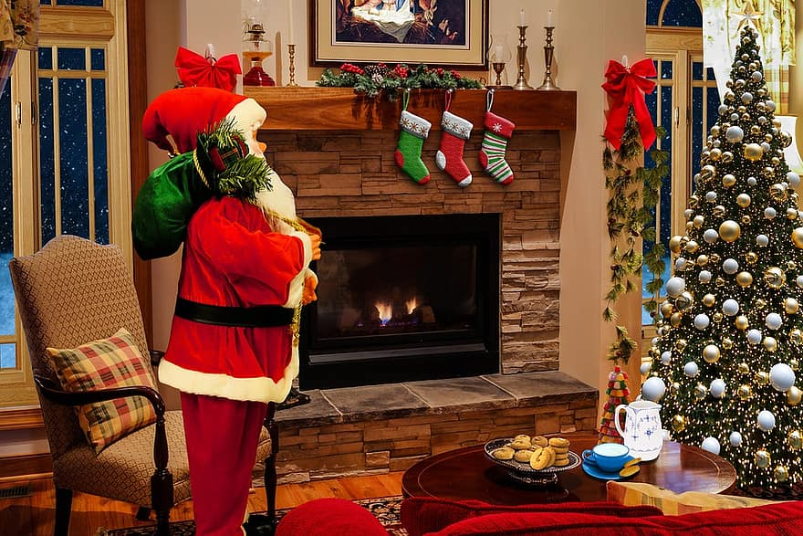
By Melina Kalogeropoulou

